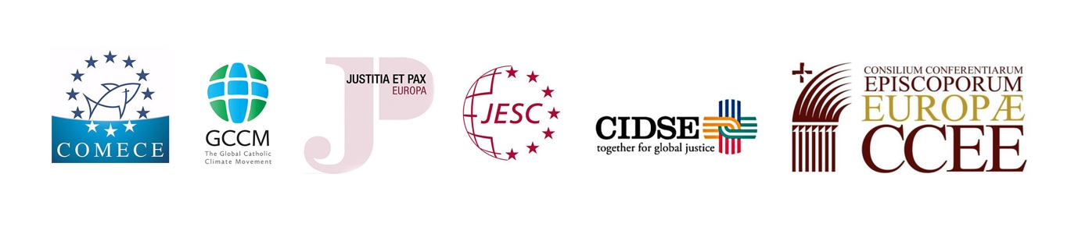
Second European Laudato Si’ Reflection Day
“towards a Life-Style conversion”

Press release, June 12th 2019

Four years after Pope Francis’ Encyclical letter on the “care for our common home”, representatives of European Bishops’ Conferences, as well as Catholic organisations and movements, held in Brussels the Second European Laudato Si’ Reflection Day on Wednesday 12 June 2019. At the core of the event, a call on Catholics and all people of good will to carry out a lifestyle conversion to answer to “the cry of the earth and the cry of the poor”.

While last year’s Reflection Day focused on the need to support a sustainable financial system, this year participants from all over Europe gathered at COMECE to share concrete initiatives and good practices addressing the complex crisis - both social and environmental – that we are all facing.

Mgr. Jean-Claude Hollerich SJ, President of COMECE, in his contribution stressed the necessity of an “ecological conversion” that implies a different lifestyle. “In my view – he stated – an ecological conversion includes both: it invites us to a deep and lasting change in our own lifestyles so that they became truly sustainable in a practical and material but also in a spiritual sense, and it requires bold policy choices that support these efforts to combat overconsumption and drastically reduce the ecological footprint at the individual and community level”.

During the meeting, an array of esteemed speakers (see the programme) delivered their perspectives and highlighted that efforts to protect and improve creation entails profound changes in lifestyles, models of production and consumption, as well as the established structures of power which govern societies. Exchanging with institutional representatives, they proposed recommendations to the EU to provide a strong impulse to such changes through policies that can promote and back sustainable lifestyles’ choices.

In the renewed setting deriving from the EU elections and in view of the Synod of the Amazon (October 2019), the Second European Laudato Si’ Reflection Day relaunched a call for the unique role of Europe at the global level, including the care for the environment, the promotion of human rights, sustainable development and economic justice.

The event was organised by the Commission of the Bishops’ Conferences of the EU (COMECE), the Council of Bishops’ Conferences in Europe (CCEE), the network of Justice and Peace Europe, CIDSE, the Global Catholic Climate Movement (GCCM), the Jesuit European Social Centre (JESC).

Media
Programme (EN)
Mgr. Hollerich Speech (EN)
Fr. Okulik’s Prayer in view of the Synod (EN)
Photo Gallery
Videos

Contact Press
COMECE Press Contact
Alessandro Di Maio
Press@comece.eu
www.comece.eu | @comeceEU
+32 22350515

CCEE Press Contact
Don Antonio Ammirati
media@ccee.eu

CIDSE Press Contact
Marta Isabel González Álvarez
gonzalez@cidse.org | @migasocial
T: +32 2 233 37 52 M: +32 491 39 54 75

GCCM Press Contact
Elena Attanasi
elena@catholicclimatemovement.global
+39 3470960836

Justice and Peace Europe Press Contact
Stefan Lunte
secretary@jupax-europa.org
+33 680179422

JESC Press Contact
Susan Dabbous
Susan.dabbous@jesc.eu
+32 470128803

